**play an audio file from SPIFFS using MAX98357A**

the following is a guide on how to play an audio file using the MAX98357A amplifier.  
for this tutorial, we used the Arduino IDE.  
**assumptions:**

* you have downloaded the Arduino IDE.
* you have configured the IDE to work with the “DOIT ESP32 DIVKIT V1” board.
* you know how to upload a file to esp32’s SPIFFS

a guide to all the steps above can be found in the “bank of knowledge”.

**needed material:**

* ESP32 microcontroller
* MAX98357A amplifier
* breadboard
* WiFi connection
* 6 wires
* earphones with an aux jack

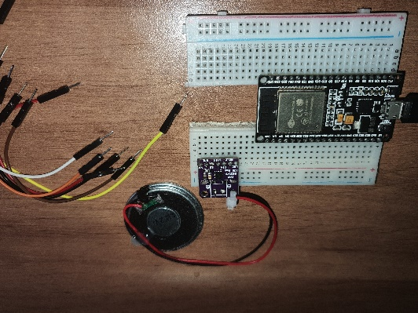

**step 1:** download the following Github repository as a zip file to your computer:  
<https://github.com/schreibfaul1/ESP32-audioI2S>  
  
**step 2:** go to the Arduino IDE -> Sketch -> include library -> add .ZIP library -> choose the file you’ve downloaded in step 1.

**step 3:** setup the wiring as shown in the “audio input and output for microcontrollers” presentation, or as follows:

|  |  |
| --- | --- |
| **MAX98357A** | **ESP32** |
| Vcc | Vcc (preferably 3.3V but can be 5V) |
| GND | GND |
| BCK or BCLK | Pin 27 (G27) |
| DIN | Pin 25 (G25) |
| LRC | Pin 26 (G26) |
| GAIN | GND |
| SD | - |

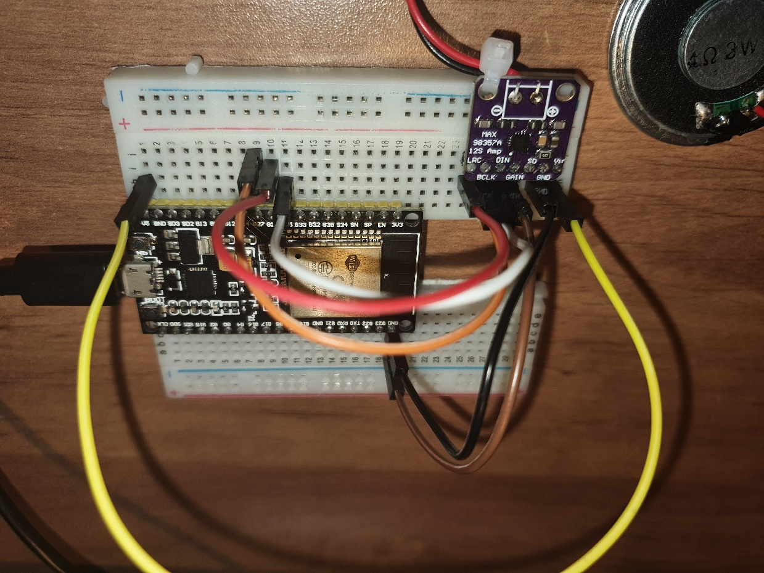

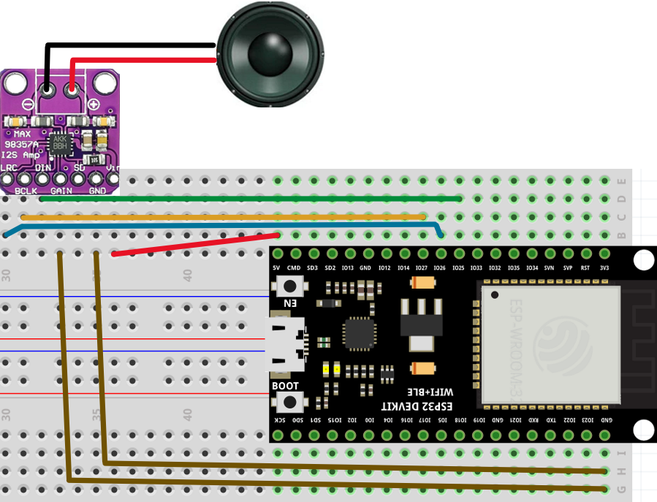

**step 4:** copy and paste the following code:

//#include "Arduino.h" //required for PlatformIO  
#include "Audio.h"  
#include "FS.h"  
  
// Digital I/O used for I2S DAC amplifier  
#define I2S_DOUT 25  
#define I2S_BCLK 27  
#define I2S_LRC 26  
  
Audio audio;  
  
void setup() {  
  
 Serial.begin(115200);  
  
 if (!SPIFFS.begin(true)) {  
 Serial.println("An Error has occurred while mounting SPIFFS");  
 return;  
 }  
  
 audio.setPinout(I2S_BCLK, I2S_LRC, I2S_DOUT);  
 audio.setVolume(20); // range 0...21 - This is not amplifier gain, but controlling the level of output amplitude.   
  
 audio.connecttoFS(SPIFFS, "123_u8.wav"); // a file with the proper name must be placed in /data folder and uploaded using "ESP32 sketch upload" plugin  
  
 audio.setFileLoop(true); //this causes the file to play in an endless loop  
}  
  
void loop()  
{  
 audio.loop();  
 if (Serial.available()) { // put streamURL in serial monitor  
 audio.stopSong();  
 Serial.println("audio stopped");  
 log_i("free heap=%i", ESP.getFreeHeap());  
  
 }  
}

**NOTE:** make sure that the defined Pins match the wiring, and that the file name matches the one you uploaded to SPIFFS.

**step 5:** connect the ESP32 to your computer, compile and run the code. you might need to press on the “reset” button on your ESP32.  
**NOTE:**

* the following code allows the file to play in a loop. you can change that if you want. while on loop, sometimes the audio plays for 1 or 2 times only for some unknown reason. changing the port which the esp32 is connected to seems to help!

**step 6:** enjoy 😊